**Question no = 1 the time required for servicing transmission is normally distributed with mean = 45 minutes and sigma = 8minutes . the service manager plans to have work begin on the transmission of a customer cars 10 minutes after the car is dropped off and the customer is told that the car will be ready within 1 hour from drop off . what is the probability that the service manager cannot meet his commitment ?**

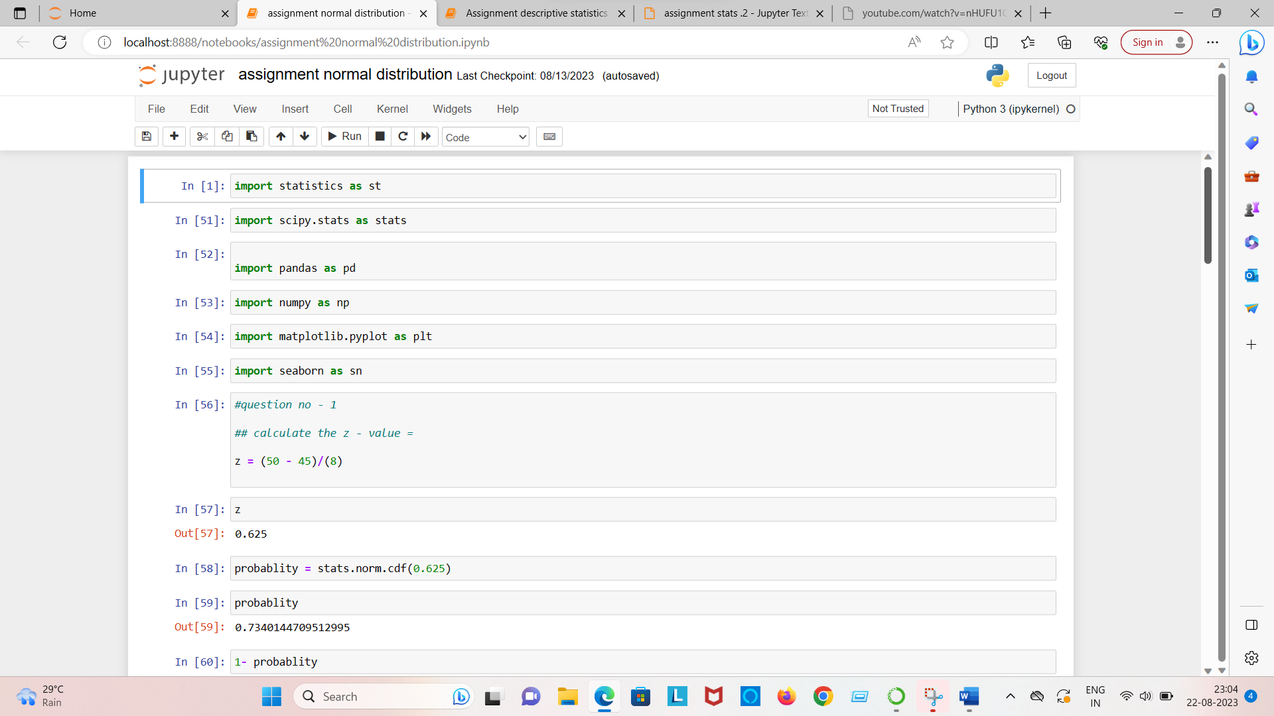

Answer no 1 = 0.256

Question no = 2 The current age (in years) of 400 clerical employee at an insurance claims processing center is normally distributed with mean mean = 38 and standard deviation sigma = 6 , for each statement below , please specify True/False , if false , briefly explain why

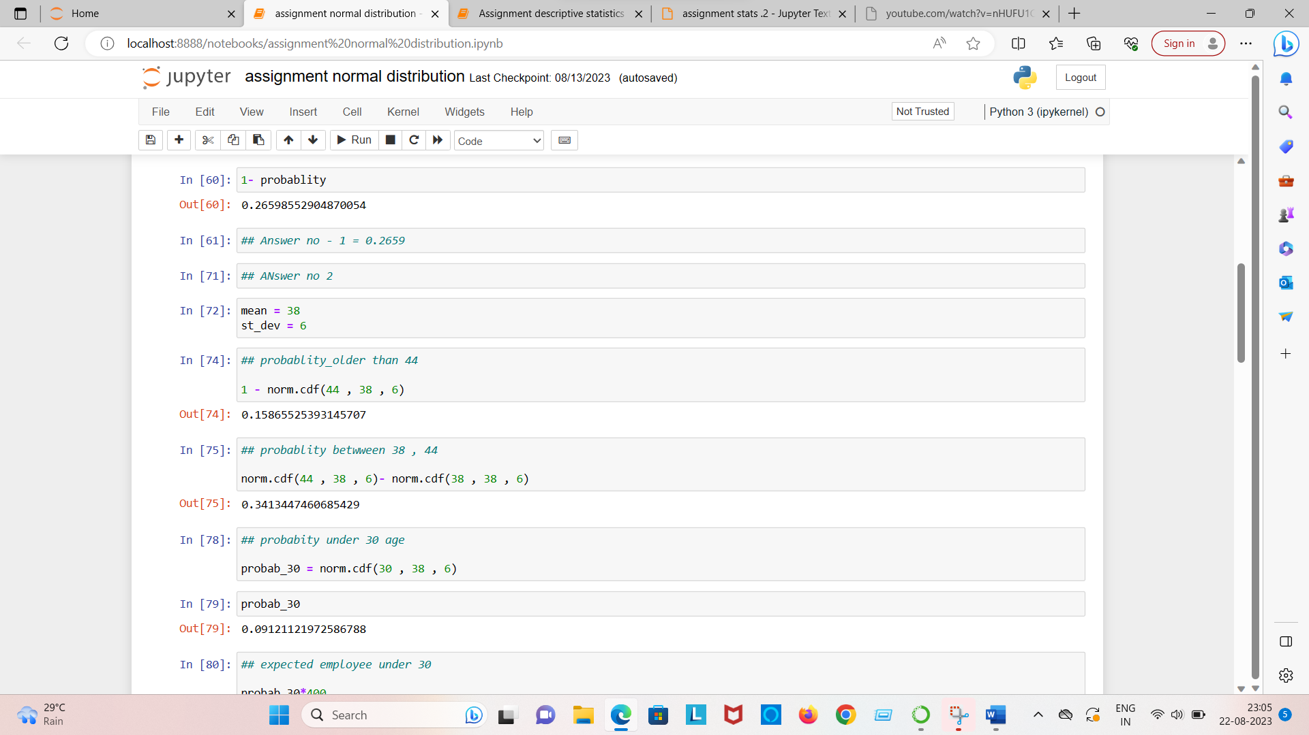

Answer no = 2

employee under the age 30 = 36.48

**Question no = 3**

**discuss both their distribution and parameters.**

**Answer no – 3**

**The normal distribution has its link with the central limit theorm, which states that’any large sum of independent identify distribution random variable are approximately normal then(x1+x2) and (2x1) tends to have normal distribution only if x1 and x2 are independent and identical distribution and n is large.**

The normal distribution has two parameter mean , variance.

Question no = 4

find the two value , a and b , symmetric about the mean such that the probability of the random variable taking a value between them is 0.99.

**Answer no = 48.5 , 151.5 (option – D)**

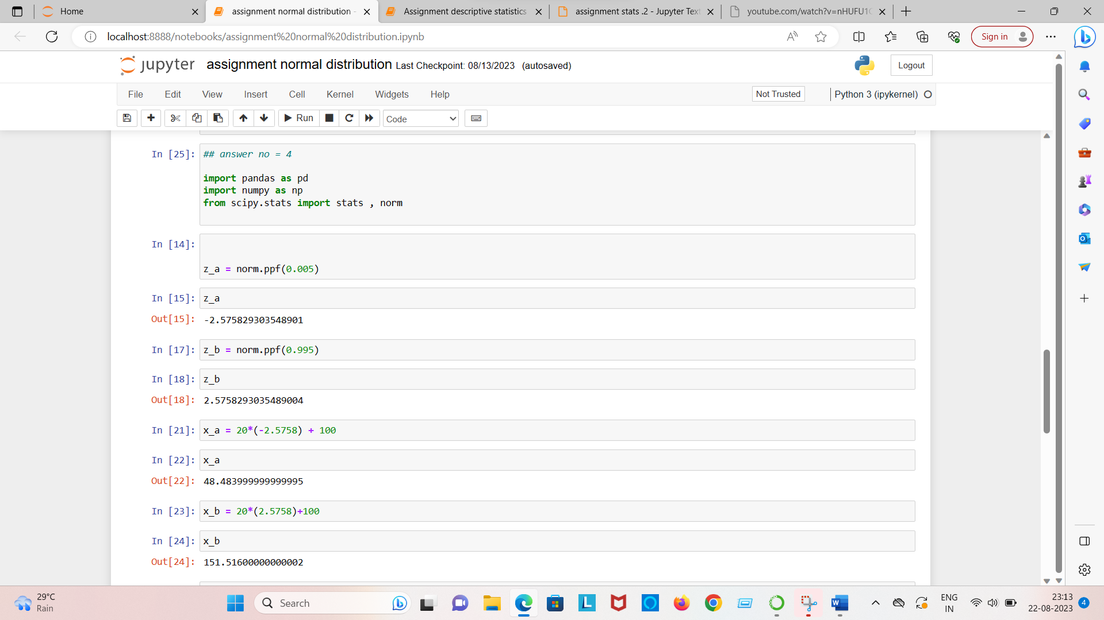

**Question no = 5**

**Answer no = 5**

1. **Rupees ranges between [9.9 to 98.1] crore rupees, 95% of the time for the annual profit of the company**
2. **The percentile of profit of company is 17 crore rupees**
3. **The division (7 , 42) has a larger probability of making a loss in a given year**

